Fusion Fuckery Rulebook v4.5
Reality is FUCKED fractured.
A massive multiversal collapse kicked off by a bunch of Reactor Meltdowns turned reality into total chaos. Angels and Blood Demons are real now. Goblins are stealing my fucking gold and some fuck ass dinosaurs strolled out of the past, and for some reason Gregg and his extended family are here too... What the fuck, Gregg?

1. The Golden Rules
When anything in this book seems to clash, these three settle it.
- The card wins. If a card's text contradicts this rulebook, do what the card says.
- Your cards, your job. You remember and trigger your own cards' effects (section 16).
- Newest first. When effects pile up, the last one played resolves first (section 11).

2. How to win
Each player starts with 30 PHP (Player Health Points). Get your opponent to 0 PHP and you win.
Your PHP drops when:
- an enemy creature hits you directly (section 13)
- a card effect deals you damage or makes you lose PHP
- you pay PHP for your own cards. You can pay yourself to 0, and then you lose. Count carefully.
- you can't draw. Running out of cards doesn't knock you out: each time you'd draw from an empty deck, you lose 5 PHP instead.
If both players hit 0 PHP at the same time, the game is a draw.

3. What you need
- A Main Deck of exactly 30 cards and a Fusion Deck of up to 10 fusions.
- Dice. Dice ATK uses a d2 (a coin works), d4, d6, d8, d10, d12 and d20. Spare dice help track damage.
- Your own coin for coin flips.
- Something both players can see to track PHP, Gold and damage on creatures: dice, paper or a phone.

4. Reading a card
Every card is a tiny contract with reality. The frame colour tells you what it is, so cards don't print their type.
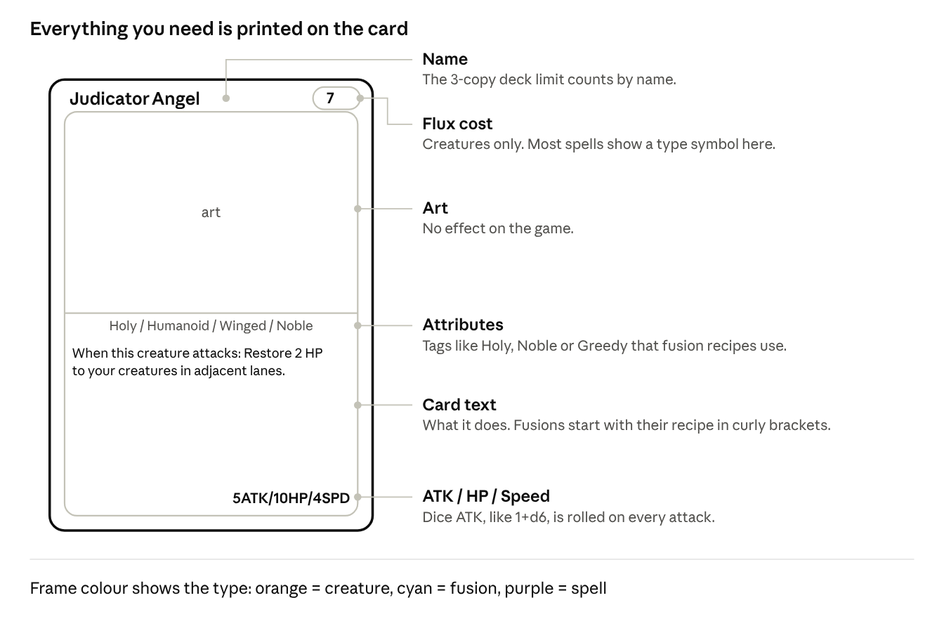
A creature card: 6 parts
- Creatures (orange) show their flux cost in the DNA badge, top right. A gold badge means it costs 5 or more flux, so it can be used to fuse (section 14).
- Fusions (cyan) have no flux cost. They come from your Fusion Deck, and their text starts with the recipe in curly brackets, like {Chapel Guard + any Holy creature}.
- Spells (purple) have no stats. A symbol top right shows the spell type; a normal Spell has none (section 11).

5. The play area
Your side mirrors your opponent's, and your 3 lanes line up with theirs.
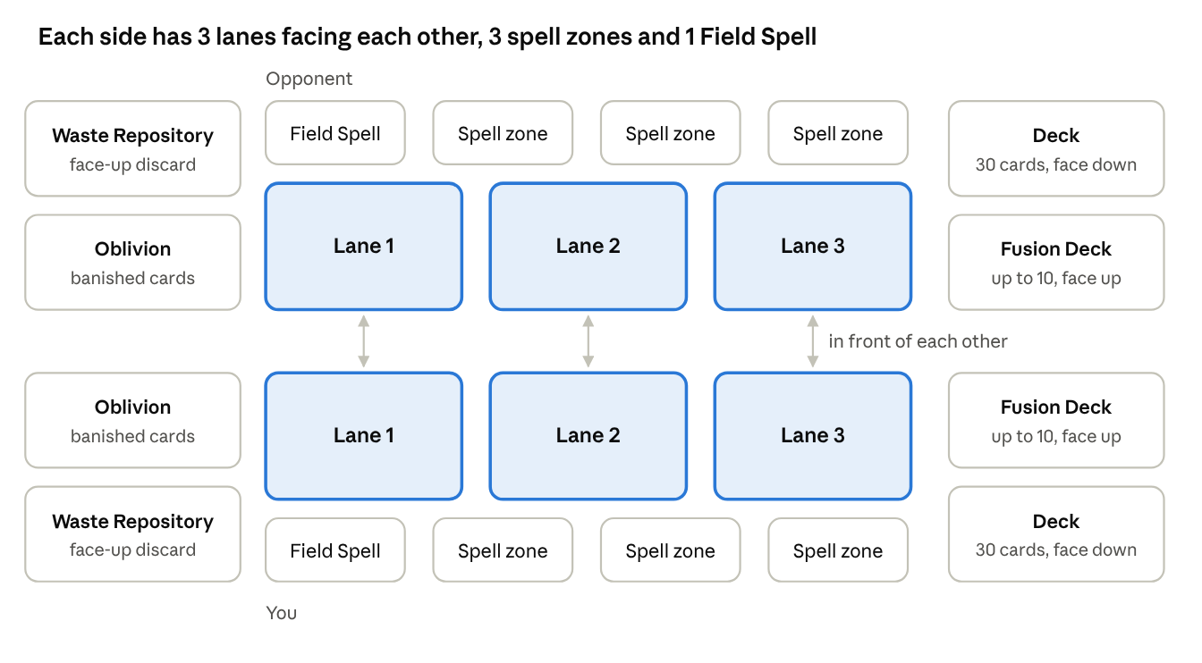
The table: both sides
Zone | What it is
Lanes (3) | Your creature zone. One creature or fusion per lane, so max 3.
Spell zones (3) | Every Spell and Instant is played into an empty spell zone, then leaves when it resolves. Continuous Spells stay. All 3 full = no more spells until one clears.
Field Spell zone (1) | Your Field Spell. 1 per player.
Deck | Your 30-card Main Deck, face down.
Fusion Deck | Your fusions, face up. Anyone can look through it.
Waste Repository | Your face-up discard pile. Used, destroyed and discarded cards go here.
Oblivion | Face up. Banished cards and cards fed to the reactor go here and never come back unless a card says so.

Hidden and public. Your hand and your deck are hidden; everything else is public. Hand size is public too: if your opponent asks how many cards you hold, tell them. Ask before touching the other player's cards.
Where things are.
- In front of: the enemy creature in the same lane, directly across.
- Lanes next to it: the lane or lanes directly left and right. The middle lane has two; the outer lanes have one. Lanes 1 and 3 aren't next to each other.

6. Building a deck
- Main Deck: exactly 30 cards (creatures and spells).
- Fusion Deck: up to 10 fusions. Fusions only go here and don't count toward the 30.
- Copies: max 3 of any card by name, in both decks.
- Mixing: any card can go in any deck.

7. Setting up
- Shuffle your Main Deck and offer it to your opponent to cut.
- Put your Fusion Deck face up next to your field.
- Both players start at 30 PHP and 0 Gold.
- Flip a coin. The winner decides who goes first.
- Each player draws 5 cards.
- Free redraw: if your opening hand has 0 or 1 creatures, you may show it, shuffle it back into your deck and draw 5 new cards. Once per game, and you keep the new hand.
- Mulligan: only if both players agree. Then both shuffle their hands back into their decks and draw 5 new cards, once.
- Start the game.
Going first vs second. The first player skips their first draw and nobody attacks on the first turn of the game. The second player gets +1 flux on their first turn (4 instead of 3).

8. Flux
Flux is what you spend to materialize and fuse creatures. Spells are free.
- You start the game with 3 max flux.
- In your Reactor Phase, except on your first turn, raise your max flux by 1, then refill it.
- Feed the reactor (optional): send 1 card from your hand to Oblivion for +1 flux this turn. Your max flux doesn't change: at 7/7 you feed and have 8/7, and next turn you go to 8/8 as normal. You can feed on your first turn too.
- Skip (optional, instead of feeding): don't raise your max flux this turn (you still refill) and draw 1 extra card. Not on your first turn; you can skip at 10 max flux too. Your normal draw always happens, whatever you choose.
- Max flux caps at 10, on your 8th turn if you never skip.
- Leftover flux doesn't do much: your next Reactor Phase refills you to your max anyway.
- Turns are counted per player: your 3rd turn is the third turn you've taken, no matter who went first.
- A discount can push a cost below 0, and then you gain the difference: a creature that costs -1 flux gives you 1 flux when you play it.
Your turn | 1 | 2 | 3 | 4 | 5 | 6 | 7 | 8+
Max flux | 3 (4 if second) | 4 | 5 | 6 | 7 | 8 | 9 | 10

9. Turn structure
Seven phases, in this order, every turn. Say each one out loud as you go.
# | Phase | What happens
1 | Draw | Draw 1 card. The first player skips this on their first turn.
2 | Reactor | Max flux +1 (not on your first turn), then refill your flux. You may also Feed (a card from your hand to Oblivion: +1 flux this turn) or Skip (no +1 max flux, draw 1 extra card).
3 | Start | Radiance bonuses from your last turn end, then resolve start-of-turn effects.
4 | Main 1 | In any order: materialize creatures, play spells, use effects. One fusion (section 14).
5 | Battle | Attack (section 13). Nobody attacks on the first turn of the game, and creatures that arrived this turn can't attack.
6 | Main 2 | Play spells and use effects. No materializing from your hand and no fusing.
7 | End | End-of-turn effects, then discard down to 8 cards.

10. Materializing creatures
From your hand (natural materialize). Only in Main Phase 1. Pay the creature's flux cost, then put it in any empty lane. You can materialize as many as you can pay for and fit. Some creatures let you pay PHP to reduce their flux cost (Blood Price, section 15).
By an effect (Carrion The Dark Duchess, Lord Lazarus and so on). It happens whenever the effect says, even outside Main Phase 1, and you don't pay flux. It still needs an empty lane: no room, no creature.
Either way:
- "When materialized" effects trigger.
- Creatures can't attack the turn they arrive. A creature or fusion that was materialized, fused or brought back this turn waits until your next turn to attack. It still hits back when it's attacked, except a fusion, which arrives winded (section 14). Taking control of a creature (Space Squid) isn't arriving, so that creature can attack, and neither is moving to another lane (Boss's Orders).
- A creature stays in its lane. It only moves if a card says it may.

11. Spells and chains
Spells cost no flux. Every spell is played into an empty spell zone (you have 3); a Field Spell goes in your Field Spell zone.
Symbol | Type | When you can play it | What it affects | Where it goes after
No symbol | Spell | Your Main Phases only. Never in response. | What its text says | Resolves, then your Waste Repository
 | Instant Spell | Your Main Phases, on your opponent's turn, during combat, or in response to any card or effect | What its text says | Resolves, then your Waste Repository
 | Continuous Spell | Your Main Phases | You: your side of the field | Stays in its spell zone until something removes it
 | Field Spell | Your Main Phases | Everything on the field, both sides | Stays in your Field Spell zone. 1 per player: a new one sends your old one to the Waste Repository

The symbol in a spell's top-right corner shows its type: a lightning bolt for Instant Spells, a circle of arrows for Continuous Spells and a mountain for Field Spells. A normal Spell has no symbol.
Chains. Whenever a card or effect is played or used, the other player may respond with an Instant. Then the first player may respond to that, and so on. When both players pass in a row, everything resolves newest first.
Example: you play Spell A. Your opponent responds with Instant B. You respond with Instant C. Both pass. C resolves first, then B, then A.
Creature effects. "Once per turn: ..." effects are used in your Main Phases unless the card says otherwise. "When...", "Whenever..." and "At the end of..." effects happen whenever they trigger.

12. Health, damage and destruction
Nothing heals on its own: damage stays until a card restores it.
Player health (PHP). You start at 30. Restoring can't take you above 30; gaining can.
Card says | What happens
Restore PHP | Heals you, but never above 30, your starting PHP.
Gain PHP | Adds PHP. Can take you above 30.
Pay PHP | A cost. You can always pay it, even to 0, and then you lose.
Lose PHP | Any drop in PHP: damage, paying, or "lose X PHP". Beelzechud and Beelzechad care about this.

Creature health. HP is written current/max: a 3/5 creature has 3 HP left out of 5.
Card says | What happens | 1/3 creature, 3 HP
Restore X HP | Heals current HP, never above max; Radiance turns the extra into a bonus (section 15). Max doesn't change. | becomes 3/3
Give X HP, or "+X HP" | Permanent. Raises current and max HP. | becomes 4/6
Permanently lose X HP | Lowers current and max HP. At 0 the creature is destroyed. | becomes 0/0, destroyed
Damage | Lowers current HP. It stays. | becomes 0/3, destroyed

Destroyed. A creature at 0 HP or less is destroyed and goes to its owner's Waste Repository. "Destroyed", "dies" and "killed" all mean the same. Sacrificing a creature destroys it as a cost.
Banished. The card goes to Oblivion. It isn't destroyed, so death effects don't trigger, and it never comes back unless a card says so.
Death effects trigger after the card reaches the Waste Repository. If several die at once, the player whose turn it is resolves theirs first, in the order they choose.
Prevent and reduce. Prevent stops damage, reduce lowers it. Damage reduced to 0 counts as no damage dealt, so nothing that triggers on taking damage fires.

13. Combat
The attacker picks the target and gets +1 Speed, and speed decides who hits first. There's no blocking, but attacking leaves a creature winded (below).
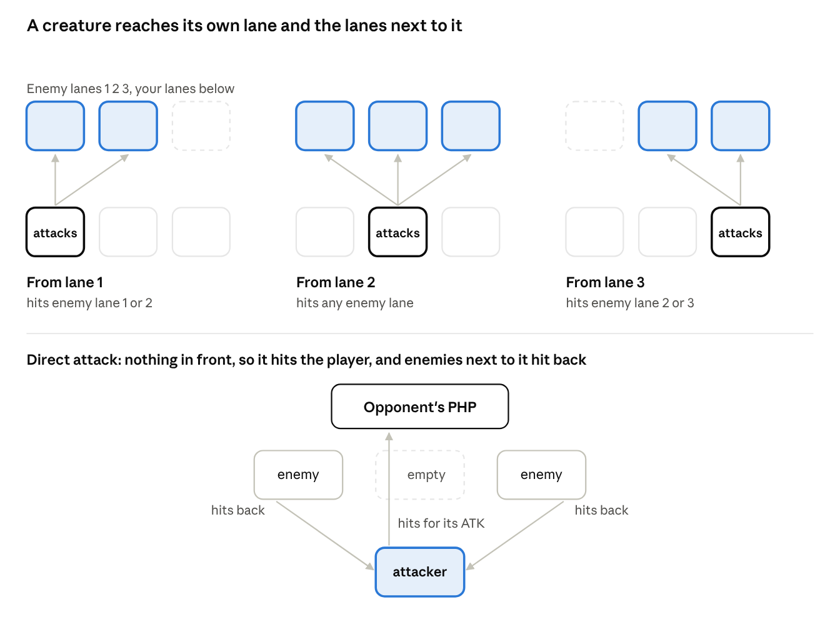
Who can hit what: 3 lanes
Attacking, step by step.
- In your Battle Phase, pick one of your creatures. Each creature can attack once per turn, one attack at a time.
- Choose its target: the enemy creature in front of it, or in a lane next to it. The middle lane reaches all three enemy lanes.
- Or attack the player. Only if nothing is in front of it. Enemy creatures in the lanes next to it hit it back with their ATK. Winded ones still hit back too, but always last.
- Response window. The defending player, then the attacking player, may play Instants. "When this creature attacks" effects trigger now, when the attack is declared.
- Resolve the fight using speed (below). The damage stays (section 12).
Nobody attacks on the first turn of the game. Creatures can't attack the turn they're played, and fusions can't attack the turn they're made. They still hit back when attacked.
Winded. A creature that attacks is winded until the start of your next turn, and so is a fusion the turn it's made (section 14). A winded creature can't hit back when it's attacked. It still stands in its lane, so an enemy in front of it still can't attack you directly, and its effects still work. Attacking is a choice: the creature that hits now can't defend itself on your opponent's turn.
Winded on a direct attack. When an enemy attacks you directly from a lane next to a winded creature of yours, the winded creature still hits it back, but always last: after the attacker has hit you and after your other creatures have hit back, whatever its speed.

Speed
Speed runs from 1 to 4; 2 is normal.
- Attacker's advantage: the attacking creature gets +1 Speed for its attack.
- The faster creature deals its damage first.
- On a tie (after the +1), the attacker goes first.
- If the first hit destroys the other creature, it doesn't hit back.
- Direct attacks: enemies next to the attacker that are faster than it (counting its +1) hit it before it reaches the player. If they destroy it, the player takes nothing. Slower ones hit it after, and winded ones hit it last.
- Twisted Dimensions (Field Spell, both players) reverses all of this: the slower creature strikes first, and the attacker gets -1 Speed instead of +1. Ties still go to the attacker.
- Creatures with dice ATK roll for each attack and each hit back (section 15).
Fight | Speed | Result
Judicator Angel (4 ATK, 10 HP, Speed 4) attacks Carrion The Dark Duchess (3 ATK, 10 HP, Speed 2) | Judicator 4 + 1 = 5 vs Duchess 2: Judicator first | Duchess drops to 6/10 and hits back for 3. Judicator ends at 7/10.
Vein Ripper (4 ATK, 4 HP, Speed 3) attacks Cherub (1 ATK, 2 HP, Speed 3) | Vein Ripper 3 + 1 = 4 vs Cherub 3: Vein Ripper first | Cherub is destroyed and never hits back. Vein Ripper stays at 4/4.
Carrion The Dark Duchess (3 ATK, 10 HP, Speed 2) attacks Vein Ripper (4 ATK, 4 HP, Speed 3) | Duchess 2 + 1 = 3 vs Vein Ripper 3: a tie, so the attacker goes first | Duchess hits first: Vein Ripper drops to 1/4, then hits back for 4. Duchess ends at 6/10.
Judicator Angel attacks the player. In the lanes next to it: Beelzechud (5 ATK, Speed 3) and Blood Imp (1 ATK, Speed 2) | Judicator 4 + 1 = 5 vs 3 and 2: Judicator first | The player takes 4. Then Judicator takes 5 + 1 and ends at 4/10.

14. Fusion
Fusions are the end goal: every fusion is built to be stronger than any creature you can materialize, and it frees up a lane.
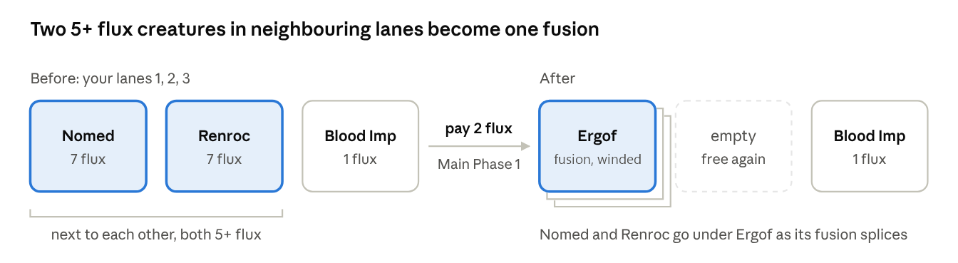
Fusing Ergof: before and after
How to fuse.
- Once per turn, in Main Phase 1, pay 2 flux.
- Choose 2 creatures you control in lanes next to each other, both with a printed cost of 5 or more flux (a gold flux badge). Fusions count as 5+ flux, so you can fuse two fusions too.
- They must meet the recipe of a fusion in your Fusion Deck.
- Put both under the fusion card. They're its fusion splices now, not creatures.
- Put the fusion in either of their lanes. The other lane is free again.
Not allowed: two creatures in lanes 1 and 3 (they aren't next to each other), a fusion splice that costs less than 5 flux (unless Ritual Pit or Melting Pot says so), or a second fusion in the same turn.
The fusion keeps the damage. The fusion arrives at its own printed stats, minus all the damage its fusion splices had. If that damage is its HP or more, it's destroyed straight away.
Example: you fuse a creature at 4/5 HP (1 damage) and one at 5/10 HP (5 damage). The fusion normally has 26 HP, so it arrives at 20/26.
The fusion is winded. It has just arrived, so it can't attack until your next turn, and it's winded until then too: it can't hit back when it's attacked (section 13).
Ways around the 2 flux.
Card | Type | What it does
It's Free Fuse-Estate | Spell | Fuse without paying the 2 flux
Crimson Altar | Field Spell | Sacrifice another Unholy creature instead of paying the 2 flux

Cheaper fusion splices.
Card | Type | What it does
Ritual Pit | Continuous Spell | Once per turn, banish an Unholy creature from your Waste Repository: your next fusion this turn may use an Unholy creature costing 3 or 4 flux as one of its fusion splices
Melting Pot | Field Spell | Any creature that meets a recipe can be a fusion splice, whatever it costs. Works for both players

Fusing from your hand. Shotgun Wedding (Spell) fuses a creature you control with a creature card from your hand. Everything else works as normal: the recipe, the 5+ flux rule, the 2 flux and one fusion per turn. The fusion takes your creature's lane, and the card from your hand never enters the field.
Reading a recipe.
Recipe says | You need
{Nomed The Dark Viscount + Renroc The Dark Marquis} | Those exact two cards
{Chapel Guard + any Holy creature} | Chapel Guard, plus any creature with the Holy attribute
{any 2 Greedy creatures} | Any two creatures with the Greedy attribute

A creature with two matching attributes can fill either part: Hemogoblin is both Greedy and Unholy. Fusions have attributes too, so a fusion can fill an attribute part.
Fusion splices. Every fusion does something with the cards under it. Some effects count them ("for each fusion splice under this creature"); others let you banish a fusion splice for an effect. Banished splices go to their owner's Oblivion.
- Every card in the stack counts. A normal fusion has 2 fusion splices. Fuse two fusions that each have 2, and the new fusion has 6: the two fusions and their 4 splices.
- Banish from the bottom. You can only banish a card that has nothing under it. A fusion in the stack can only be banished once all its own splices are gone.
What carries over. Only damage. A fusion only has the effect printed on its own card. Its fusion splices' effects and stat changes don't carry over.
When a fusion leaves the field. If it's destroyed, the fusion card and every card under it go to their owners' Waste Repositories. Only the fusion's own death effects trigger; its fusion splices' death effects don't. If it leaves any other way (banished, say), the fusion card goes where the effect says and the cards under it still go to the Waste Repository.
Unfuse. The fusion goes back to its owner's Fusion Deck. The cards directly under it come back onto the field at full HP, on their owner's side: one in the fusion's lane, the rest in empty lanes (with no empty lane, a card goes to the Waste Repository). A fusion splice that is itself a fusion comes back as that fusion, with its own splices still under it.
- The damage is split. The fusion's damage is shared evenly between its fusion splices, half each for the usual two (the bigger one takes an odd point). A banished splice's half is simply gone.
- It never kills. Unfusing never takes a splice below 1 HP.
- Winded stays winded. If the fusion was winded, the splices come back winded.
Example: a fusion at 10/20 was made from a 10 HP and a 7 HP creature. Unfused, each takes 5: they come back at 5/10 and 2/7. Even a fusion at 2/30 only leaves them at 1/10 and 1/7.
Mixing decks. Most recipes ask for an attribute rather than a specific card, so creatures from different decks can fuse together.

15. Keywords
Some cards carry a keyword that bends the rules.

Radiance
A creature with Radiance never wastes healing. When HP restored to it would go past its max HP, the extra becomes your choice of, until your next turn:
- that much +ATK, or
- that much +HP over its max (overhealth).
Its max HP doesn't change, and the bonus goes away at the start of your next turn.
Example: Acolyte Adam restores 2 HP to a Cherub at full HP (2/2). Cherub has Radiance, so you choose: +2 ATK, or 2 extra HP (4/2), until your next turn.
So +ATK helps it hit harder this turn, and +HP helps it survive your opponent's turn.

Blood Price
Some creatures say Pay 3 PHP per flux: Reduce this creature's flux cost by up to Y. When you materialize one from your hand, you can take any amount off its flux cost, up to Y, and pay 3 PHP for each flux you take off. A creature that can only drop 1 flux just says "Pay 3 PHP: Reduce this creature's flux cost by 1." Paying PHP is what lets you play them early.
Example: Vein Ripper costs 3 flux and says "Pay 3 PHP per flux: Reduce this creature's flux cost by up to 2." You can play it for 3 flux, for 2 flux and 3 PHP, or for 1 flux and 6 PHP.
The printed cost still counts for fusing: a creature printed at 5+ flux can fuse even if you paid less (section 14).

Dice ATK and Gold
Dice ATK. A creature's ATK can be a roll, like 1+d6. Roll it every time it attacks, for that attack only, and again whenever it hits back in a fight. "Natural 20" or "natural 1" means the die itself showed that number.
Gold. Everyone starts with 0 Gold and there's no cap. Only cards that mention Gold can make, spend or move it. Invested Gold is locked into that card: you can't take it back, and it's lost if the card leaves the field.

Fluffy (Plushies)
Plushies are plush versions of other creatures. They keep the original's attributes and add Fluffy, so a Plush Judicator Angel still counts as a Holy creature for recipes.
- They need a Claw Machine. You can only materialize a Fluffy creature, from your hand or by an effect, while you control a Claw Machine (Field Spell).
- No machine, no plushies. If you stop controlling a Claw Machine (it's destroyed, you replace it with another Field Spell, or your opponent takes control of the plushy), your Fluffy creatures are destroyed at once.
- What the Claw Machine does: your Fluffy creatures cost 1 less flux. They can attack your opponent directly even when an enemy creature is in front of them, unless your opponent controls a Fluffy creature. They slip past the creature in front, so it doesn't hit back, but the creatures in the lanes next to the attacker still do, as on any direct attack. And once per turn, when one of your Fluffy creatures is destroyed, you draw a card.
- Finding the machine. Arcade Kid and Plush Collector aren't Fluffy, so they work without a Claw Machine; they search your deck for one. Plush Catalogue searches for any card with "Plush" in its name.
Example: your Plush Vein Ripper is in lane 1 and an enemy Cherub is in front of it. With your Claw Machine out, it attacks your opponent directly: the Cherub doesn't hit back, but an enemy in lane 2 does.

16. Advanced rules
The stuff you'll end up arguing about at 1am.
Forgotten effects. A forgotten optional effect ("may", or anything that helps you) is gone. A forgotten mandatory one is resolved if someone notices it the same turn; after that, let it go. Your opponent doesn't have to remind you, but being decent about it is encouraged.
Reading card text.
Card says | Means
"At the start / end of your turn" | Your own turn only
"Each turn", "every turn" | Both players' turns
"Until end of turn", "this turn" | Wears off at the end of the current End Phase
"Any creature", "a creature on the field" | Either side
"You control", "your field" | Your side only
"Enemy creature" | A creature your opponent controls
"Half of..." | Round down

Negate. A negated creature has no card text until the negation ends. Its stats, name and attributes stay, and anything it already did stays done.
Owner and controller. The owner is the player whose deck a card started in; the controller is whoever has it on their side now. A card going to a hand, deck, Waste Repository or Oblivion always goes to its owner's.
Hand limit. 8 cards, checked at the end of every turn. Discard the extra into your Waste Repository.
Searching your deck. Shuffle afterwards and offer your opponent the cut.
Once per turn / once per game. Counted per effect: 3 copies of the same card still get one use.
Targeting. An effect targets when it chooses a specific card. Attacking isn't targeting, so an untargetable creature can still be attacked.
Simultaneous effects. The player whose turn it is resolves theirs first, in the order they choose, then the other player.
Coin flips. Each player flips their own coin. No coin, no flips.

17. Quick reference
Starting PHP | 30. Restoring can't take you above 30; gaining can
Main Deck / Fusion Deck | 30 / up to 10, max 3 copies of a card
Opening hand | 5. One free redraw if it has 0 or 1 creatures; mulligan only if both players agree
Arriving | Creatures and fusions can't attack the turn they arrive
Draw per turn | 1 (the first player skips their first)
Flux | starts at 3, +1 a turn, max 10. Going second: +1 on your first turn
Reactor Phase | +1 max flux and refill. You may also Feed (a card to Oblivion: +1 flux this turn) or Skip (no +1, draw 1 extra card)
Lanes / spell zones / Field Spells | 3 / 3 / 1 per player
Attacks | each creature once per turn, own lane or the lanes next to it
Speed | 1-4, 2 is normal. The attacker gets +1, faster strikes first, the attacker wins ties
Winded | A creature that attacked, or a fusion just made, can't hit back when attacked until your next turn. On a direct attack it still hits back, last
Fusing | once per turn, 2 flux, two 5+ flux creatures (gold badge) or fusions in neighbouring lanes. The fusion keeps their damage and is winded
Unfuse | the splices come back at full HP, split the fusion's damage (never below 1 HP) and stay winded if it was
Empty deck | lose 5 PHP for each draw you can't make
Hand limit | 8
Gold | starts at 0, no cap

18. Glossary
Term | Meaning
Attribute | A tag like Holy, Unholy, Noble or Greedy. Does nothing on its own; matters when a card or recipe names it
Banish | Send a card to Oblivion. Not destroyed, so no death effects
Banish a fusion splice | Send one card from under a fusion to its owner's Oblivion. Only a card with nothing under it (section 14)
Blood Price | A creature that lets you pay 3 PHP per flux to lower its flux cost (section 15)
Chain | A stack of responses, resolved newest first (section 11)
Continuous Spell | Stays in play and affects you (section 11)
Destroyed | At 0 HP or less, or destroyed by an effect. Goes to the Waste Repository. Same as dies or killed
Feed the reactor | In your Reactor Phase, send a card from your hand to Oblivion for +1 flux this turn (section 8)
Field Spell | Stays in play and affects everything on the field. 1 per player (section 11)
Fluffy | A plushy. Can only be materialized while you control a Claw Machine, and is destroyed if you stop controlling one (section 15)
Flux | What you spend to materialize and fuse creatures (section 8)
Fusion | A creature made from 2 fusion splices, kept in your Fusion Deck until fused (section 14)
Fusion splice | A card under a fusion: the 2 cards it was made from, and everything under them (section 14)
Gain PHP | Add PHP. Can take you above 30
Give HP | Permanently raise current and max HP
Gold | A resource some cards make and spend (section 15)
In front of | The enemy creature in the same lane, directly across
Lane | One of your 3 creature spots. Lane 2 is the middle
Lanes next to it | The lane(s) directly left and right. The middle lane has two, the outer lanes have one
Lose PHP | Any drop in PHP: damage, paying, or "lose X PHP"
Materialize | Put a creature onto the field, from your hand or by an effect (section 10)
Negate | Switch off a creature's card text (section 16)
Oblivion | Where banished cards and cards fed to the reactor go. They don't come back
PHP | Player Health Points. You start with 30
Radiance | A creature with Radiance turns healing past its max HP into +ATK or +HP until your next turn, your choice (section 15)
Restore HP | Heal up to max HP; max doesn't change
Restore PHP | Heal PHP, never above 30
Sacrifice | Destroy your own creature as a cost
Skip | In your Reactor Phase, don't raise your max flux and draw 1 extra card instead (section 8)
Speed | Decides who strikes first in a fight, 1 to 4. Attackers get +1 (section 13)
Target | When an effect chooses a specific card. Attacking isn't targeting
Waste Repository | Your face-up discard pile
Winded | A creature that attacked, or a fusion just made. Until its controller's next turn it can't hit back when attacked; on a direct attack it hits back last (section 13)

19. Rulings
Answers to questions that come up in play.

Rules
- Feed: any card from your hand can feed the reactor. It goes face up to Oblivion. Feeding (or Overclock) can take you above 10 flux for that turn; max flux never goes above 10.
- Skip: you still make your normal draw. At 10 max flux, skipping costs you nothing.
- Winded ends at the start of its controller's next turn. A winded creature still blocks its lane and its effects still work.
- Arriving: a creature brought back by an effect (Lord Lazarus, Microwave, Carrion The Dark Duchess, Unfuse) has arrived, so it can't attack that turn. Moving to another lane (Boss's Orders) isn't arriving.
- Fusing a fusion: two fusions in lanes next to each other can be fused if they meet a recipe, just like two creatures. A fusion can even fuse into another copy of itself from your Fusion Deck, which grows its stack.
- Damage that carries over is the damage the splices had when you fused. Overhealth from Radiance doesn't count as extra HP for this.

Cards
- Space Squid: the creature moves to an empty lane on your side and can attack this turn. At the end of the turn it goes back to its old lane, or another empty one; with no empty lane it goes to its owner's Waste Repository. If you sacrifice it or use it as a fusion splice, it doesn't come back: it stays under your fusion until that fusion leaves the field, then goes to its owner's Waste Repository (or back to its owner's side, if your fusion is unfused). That works on an enemy fusion too.
- Microwave: takes creatures, not fusions, from either player's Waste Repository. "When materialized" effects trigger.
- Unfuse: see section 14. The splices don't count as materialized, so "when materialized" effects don't trigger.
- Lord Lazarus: comes back once for each fusion splice you can banish from under it, each time at half its printed stats (4 ATK / 11 HP / 1 Speed) and with its remaining splices still under it.
- Seraphim Wall: can save itself too. Each save costs one fusion splice.
- Scrooger: only takes creatures you controlled that went to a Waste Repository, not fusions or banished cards. A creature that Lord Lazarus is bringing back can't be taken.
- Hop Goblin: with Goblin King or Goblin General out it still rolls at least twice; it uses whichever gives more rolls.
- Beelzechad: banishing a splice instead of losing 2 PHP is your choice each turn.
- Melting Pot, Twisted Dimensions: Field Spells affect both players, so your opponent can fuse cheap creatures with your Melting Pot too.
- Boss's Orders: can move your creature or an enemy one, always to an empty lane on its own side.
- Shotgun Wedding: the creature from your hand counts as a fusion splice but never entered the field, so its "when materialized" effects don't trigger and it carries no damage.
- Blood Ledger is a Continuous Spell now, so it takes one of your 3 spell zones instead of your Field Spell zone.
- Claw Machine: it only helps its owner's plushies. If both players control a Fluffy creature, neither side's plushies can slip past. Pipebomb on a Claw Machine destroys every Fluffy creature its owner controls when it explodes.
- Space Squid on a plushy: the plushy changes sides. Its new controller has no Claw Machine for it, so it's destroyed straight away (unless they have their own).
- Mega Plush: protects only your own Claw Machine, one fusion splice per save.
- Patchwork Plush: counts every Fluffy creature and Fluffy fusion in your Waste Repository, including ones that were destroyed when your Claw Machine left.
- Plush Catalogue can find another Plush Catalogue, but never the Claw Machine itself (it has no "Plush" in its name). Plush Collector can.
- Beelzechad: only creatures it destroys in combat trigger its 2 damage.
- Goblin Pit Boss: its reroll is an activated effect, so only on your own turn. It can reroll any Greedy creature's die.
- Goblin Miner: once per turn counts per card name, so several Miners still pay for 1 flux per turn.
- Goblin Stock Broker: if nobody can look the price up, flip a coin.
- Market Research: if your deck has no Greedy creature, the gold is still paid.
- Loaded Dice: rerolls one die roll or coin flip, yours or your opponent's.
- Sanctuary Bells: heals Holy creatures on both sides. Radiance applies.
- Seraphim Wall and Sanctified Knight stack: a creature next to both takes 2 less combat damage.
- Mountain Orc: natural 20 and natural 1 only count on its own attacks, not when it hits back.
- Renroc, Ergof: "4 (or 6) or less HP" means current HP. Chapel Guard survives the first destroy effect too.
- Blood Imp: if your opponent controls a creature, you must pick a creature.

